James Peacemaker

April 12, 2021

CPSC 405

Thread Message Queue Project

Answer Document

Testing

* Place screen shots of your testing here.

Test case 1: basic message example

With all messages.

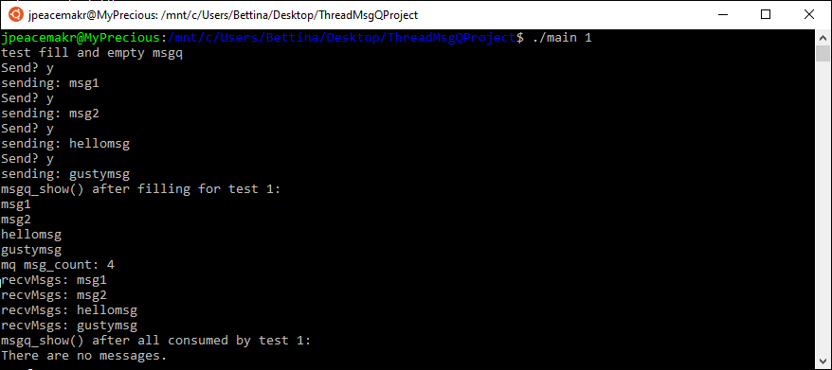

With just one message.

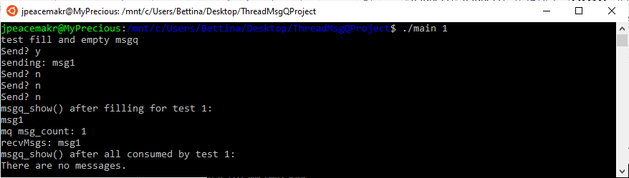

With no messages.

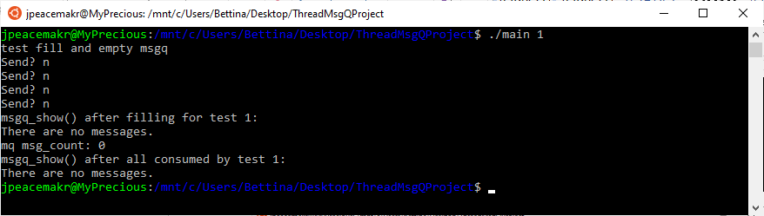

Test case 2: Uses passiton(). Each just keeps looping, so I cut them off.

With all messages.

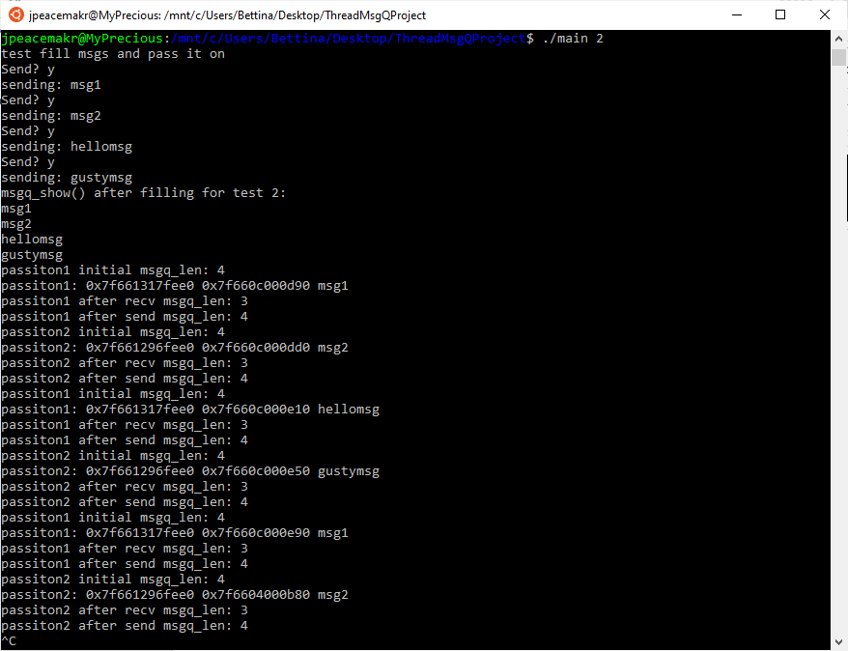

With just one message.

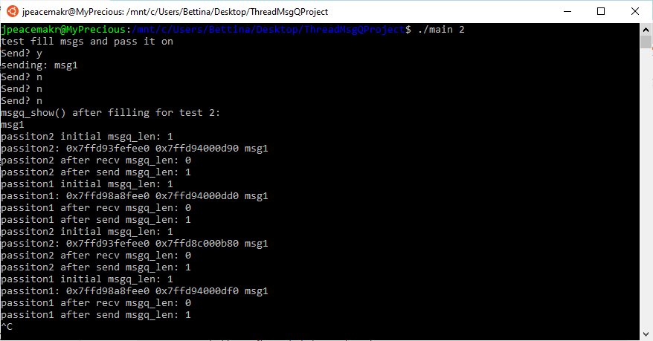

With no messages. It just loops and waits for messages.

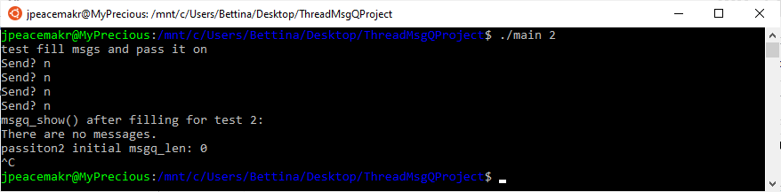

Test case 3:

Show that send_msg blocks when the message queue contains num_msgs. I increased the number of messages I could send to be more than 4.

It can’t send “finalmessage” and just waits. Due to the full semaphore still being set to 4.

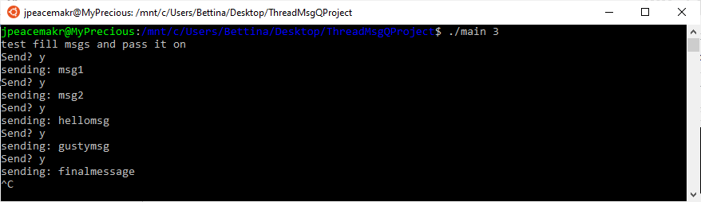

Test case 4:

Show that recv_msg blocks when the message queue is empty.

I increase msg_count (used in the for loop) to 6 so it sits waiting for more messages because of the recv_msg empty semaphore.

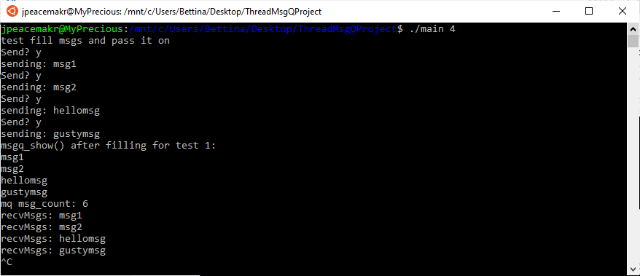

Test case 5:

Solve a producer consumer problem with your message queue and five threads.

Each producer (threads 4 and 5) sends 55 messages (110 messages total). Each consumer (threads 1, 2 and 3) receives 50 messages (possible total of 150).

All 110 messages are accounted for in the storage array after being consumed.

jpeacemakr@MyPrecious:/mnt/c/Users/Bettina/Desktop/ThreadMsgQProject$ ./main 5

thread 4 sending: msg1

thread 4 sending: msg2

thread 4 sending: msg3

thread 4 sending: msg4

thread 4 sending: msg5

thread 4 sending: msg6

thread 4 sending: msg7

thread 4 sending: msg8

thread 5 sending: msg56

thread 2 receiving: msg2

thread 2 receiving: msg4

thread 2 receiving: msg5

thread 2 receiving: msg6

thread 2 receiving: msg7

thread 2 receiving: msg8

thread 2 receiving: msg56

thread 1 receiving: msg1

thread 4 sending: msg9

thread 4 sending: msg10

thread 4 sending: msg11

thread 4 sending: msg12

thread 4 sending: msg13

thread 4 sending: msg14

thread 4 sending: msg15

thread 3 receiving: msg3

thread 3 receiving: msg11

thread 3 receiving: msg12

thread 3 receiving: msg13

thread 3 receiving: msg14

thread 3 receiving: msg15

thread 5 sending: msg57

thread 5 sending: msg58

thread 5 sending: msg59

thread 5 sending: msg60

thread 5 sending: msg61

thread 5 sending: msg62

thread 2 receiving: msg9

thread 2 receiving: msg58

thread 2 receiving: msg59

thread 2 receiving: msg60

thread 2 receiving: msg61

thread 2 receiving: msg62

thread 1 receiving: msg10

thread 3 receiving: msg57

thread 4 sending: msg16

thread 4 sending: msg17

thread 4 sending: msg18

thread 4 sending: msg19

thread 4 sending: msg20

thread 4 sending: msg21

thread 4 sending: msg22

thread 4 sending: msg23

thread 5 sending: msg63

thread 1 receiving: msg17

thread 1 receiving: msg19

thread 1 receiving: msg20

thread 1 receiving: msg21

thread 1 receiving: msg22

thread 1 receiving: msg23

thread 1 receiving: msg63

thread 2 receiving: msg16

thread 4 sending: msg24

thread 4 sending: msg25

thread 4 sending: msg26

thread 4 sending: msg27

thread 4 sending: msg28

thread 4 sending: msg29

thread 4 sending: msg30

thread 3 receiving: msg18

thread 3 receiving: msg26

thread 3 receiving: msg27

thread 3 receiving: msg28

thread 3 receiving: msg29

thread 3 receiving: msg30

thread 5 sending: msg64

thread 5 sending: msg65

thread 5 sending: msg66

thread 5 sending: msg67

thread 5 sending: msg68

thread 5 sending: msg69

thread 1 receiving: msg24

thread 1 receiving: msg65

thread 1 receiving: msg66

thread 1 receiving: msg67

thread 1 receiving: msg68

thread 1 receiving: msg69

thread 2 receiving: msg25

thread 3 receiving: msg64

thread 4 sending: msg31

thread 4 sending: msg32

thread 4 sending: msg33

thread 4 sending: msg34

thread 4 sending: msg35

thread 4 sending: msg36

thread 4 sending: msg37

thread 4 sending: msg38

thread 5 sending: msg70

thread 2 receiving: msg32

thread 1 receiving: msg31

thread 1 receiving: msg35

thread 1 receiving: msg36

thread 1 receiving: msg37

thread 1 receiving: msg38

thread 1 receiving: msg70

thread 2 receiving: msg34

thread 4 sending: msg39

thread 4 sending: msg 40

thread 4 sending: msg41

thread 4 sending: msg42

thread 4 sending: msg43

thread 4 sending: msg44

thread 4 sending: msg45

thread 3 receiving: msg33

thread 3 receiving: msg41

thread 3 receiving: msg42

thread 3 receiving: msg43

thread 3 receiving: msg44

thread 3 receiving: msg45

thread 5 sending: msg71

thread 5 sending: msg72

thread 5 sending: msg73

thread 5 sending: msg74

thread 5 sending: msg75

thread 5 sending: msg76

thread 1 receiving: msg39

thread 1 receiving: msg72

thread 1 receiving: msg73

thread 1 receiving: msg74

thread 1 receiving: msg75

thread 1 receiving: msg76

thread 2 receiving: msg 40

thread 3 receiving: msg71

thread 4 sending: msg46

thread 4 sending: msg47

thread 4 sending: msg48

thread 4 sending: msg49

thread 4 sending: msg50

thread 4 sending: msg51

thread 4 sending: msg52

thread 4 sending: msg53

thread 5 sending: msg77

thread 2 receiving: msg47

thread 2 receiving: msg49

thread 2 receiving: msg50

thread 2 receiving: msg51

thread 2 receiving: msg52

thread 2 receiving: msg53

thread 2 receiving: msg77

thread 1 receiving: msg46

thread 4 sending: msg54

thread 4 sending: msg55

thread 5 sending: msg78

thread 5 sending: msg79

thread 5 sending: msg80

thread 5 sending: msg81

thread 5 sending: msg82

thread 2 receiving: msg54

thread 2 receiving: msg78

thread 2 receiving: msg79

thread 2 receiving: msg80

thread 2 receiving: msg81

thread 2 receiving: msg82

thread 1 receiving: msg55

thread 5 sending: msg83

thread 5 sending: msg84

thread 5 sending: msg85

thread 5 sending: msg86

thread 5 sending: msg87

thread 5 sending: msg88

thread 5 sending: msg89

thread 3 receiving: msg48

thread 3 receiving: msg85

thread 3 receiving: msg86

thread 3 receiving: msg87

thread 3 receiving: msg88

thread 3 receiving: msg89

thread 1 receiving: msg84

thread 5 sending: msg 90

thread 5 sending: msg91

thread 5 sending: msg92

thread 5 sending: msg93

thread 5 sending: msg94

thread 5 sending: msg95

thread 5 sending: msg96

thread 2 receiving: msg83

thread 2 receiving: msg92

thread 3 receiving: msg 90

thread 3 receiving: msg94

thread 3 receiving: msg95

thread 3 receiving: msg96

thread 1 receiving: msg91

thread 5 sending: msg97

thread 5 sending: msg98

thread 5 sending: msg99

thread 3 receiving: msg97

thread 3 receiving: msg99

thread 1 receiving: msg98

thread 5 sending: msg100

thread 5 sending: msg101

thread 5 sending: msg102

thread 5 sending: msg103

thread 5 sending: msg104

thread 5 sending: msg105

thread 5 sending: msg106

thread 2 receiving: msg93

thread 2 receiving: msg102

thread 2 receiving: msg103

thread 2 receiving: msg104

thread 2 receiving: msg105

thread 2 receiving: msg106

thread 1 receiving: msg101

thread 5 sending: msg107

thread 5 sending: msg108

thread 5 sending: msg109

thread 5 sending: msg110

thread 3 receiving: msg100

thread 3 receiving: msg109

thread 3 receiving: msg110

thread 1 receiving: msg108

thread 2 receiving: msg107

thread 1 received these messages: msg1 msg10 msg17 msg19 msg20 msg21 msg22 msg23 msg63 msg24 msg65 msg66 msg67 msg68 msg69 msg31 msg35 msg36 msg37 msg38 msg70 msg39 msg72 msg73 msg74 msg75 msg76 msg46 msg55 msg84 msg91 msg98 msg101 msg108

thread 2 received these messages: msg2 msg4 msg5 msg6 msg7 msg8 msg56 msg9 msg58 msg59 msg60 msg61 msg62 msg16 msg25 msg32 msg34 msg 40 msg47 msg49 msg50 msg51 msg52 msg53 msg77 msg54 msg78 msg79 msg80 msg81 msg82 msg83 msg92 msg93 msg102 msg103 msg104 msg105 msg106 msg107

thread 3 received these messages: msg3 msg11 msg12 msg13 msg14 msg15 msg57 msg18 msg26 msg27 msg28 msg29 msg30 msg64 msg33 msg41 msg42 msg43 msg44 msg45 msg71 msg48 msg85 msg86 msg87 msg88 msg89 msg 90 msg94 msg95 msg96 msg97 msg99 msg100 msg109 msg110

jpeacemakr@MyPrecious:/mnt/c/Users/Bettina/Desktop/ThreadMsgQProject$